

**Money, Banks and Quantitative Easing**

Speech given by

David Miles, Member of the Monetary Policy Committee, Bank of England

At the 14th Northern Ireland Economic Conference, Belfast 30 September 2009

I would like to thank Conall Maccoille and Helen Lawton for research assistance, and others for helpful comments. The views expressed are my own and do not necessarily reflect those of the Bank of England or other members of the Monetary Policy Committee.

1

All speeches are available online at [www.bankofengland.co.uk/publications/Pages/speeches/default.aspx](http://www.bankofengland.co.uk/publications/Pages/speeches/default.aspx)

# MONEY, BANKS AND QUANTITATIVE EASING

1. **Introduction**

We have just seen across the UK falls in output and rises in unemployment of a severity that is exceptional. Since the first quarter of 2008 the level of UK GDP has fallen by around 5.5%, the sharpest contraction of economic activity in the post-war period; on the Labour Force Survey measure around 2.5 million people in UK are now unemployed. Northern Ireland, which in some ways has a very different economy from much of the rest of the UK, nonetheless experienced a similarly painful period of sharply falling production, rising unemployment and very big declines in property prices. The latest data from the Office of National Statistics (ONS) indicate that in the three months May- July the employment rate in Northern Ireland had fallen by just over 4pp compared with the same period in 2008, the sharpest rate of decline in the United Kingdom. The contraction of economic activity across the UK has been extraordinary, relative to history, but typical of what has happened over the past year in developed countries. This has been a global economic crisis. And as with another global economic crisis of the last century – the Great Depression – this crisis had its origins in the financial sector, and more specifically in the banking sector.

What I want to focus on is how monetary policy can be used to help us to emerge from a very deep recession and prevent inflation from deviating from target. The key challenge is to achieve this when banks remain severely damaged, and in such a way that makes a repeat of the instability of the last two years less likely. That is exceptionally difficult – but it is what is required. To throw any light upon it one needs to think how we got into the mess from which we are beginning to emerge. So I want to begin by standing back for a moment and briefly describing some of the features of the banking sector and household and corporate balance sheets as they were as we entered the crisis. When viewed with the benefits of hindsight, and seen also in the light of the longer historical record, some of those features look both remarkable and ominous.

# The lead-up to the crisis

On the eve of the crisis banks in the UK (and elsewhere) had less capital and less highly liquid assets – relative to the size of their balance sheets – than they had typically held in the past. Bank capital and liquidity at the start of this century were a fraction of what had

been normal for most of the previous century (**Charts 1 and 2**). In the middle of the twentieth century UK banks typically held about twice as much capital, relative to their assets, than has been the case in recent years. In the US banks capital ratios have been on a downward trajectory for much of the past 150 years. A more recent phenomenon in the UK is the extent to which banks have come to rely heavily upon wholesale funding, rather than deposits from customers. The so-called customer funding gap of the major UK banks (that is lending to customers not matched by customer deposits) rose from close to zero in 2000 to around £800 billion by 2008 (**Chart 3**). A substantial part of this wholesale funding proved footloose and hard to replace once fears about the strength of the banking sector emerged.

An underlying problem was that UK banks had a great many assets that had been acquired on the wrong terms; the interest rates charged on them, or the yields implicit in their purchase price, did not allow for their risks. When those risks became clear the fall in many asset values was severe. A similar problem has affected banks in many countries

* including banks based in the Irish Republic, which are particularly important for Northern Ireland.

A symptom of these problems - admittedly clearer in retrospect than it might have been at the time - was the exceptionally low levels to which the risk premia on many of banks’ recently acquired assets had fallen. For example, the spread over Bank Rate of the effective rate of interest paid on the stock and flow of mortgage lending in the UK became unusually compressed (**Chart 4**). Falling risk premia were most marked on the most risky loans. For some years preceding the crisis it had become normal for the interest rates on mortgage loans to new customers to be lower than those for existing customers. This was so even though new loans were generally much larger, relative to the value of houses they were secured against, than loans of existing customers, the great majority of whom had been regularly making payments for years. As house prices rose,

lenders perceived there to be a small probability of losses from defaults in their mortgage lending to UK households. **Chart 5** illustrates there was only a small premium for mortgage lending with a 95% loan-to-value (LTV) ratio relative to lending with a LTV of 75%. More recently this premium has increased sharply as house prices fell and lenders have expected there to be a far greater probability of losses from their mortgage lending.

Since the end of 2007 interest rates on new mortgage loans have typically been above rates on the existing stock of mortgages.

A similar phenomenon of shrinking risk premia on more risky debt took place in the corporate bond market (**Chart 6**). Companies with poorer credit ratings were able to secure debt finance at ever more favourable interest rates relative to the most credit worthy (triple-A rated) companies. However, as economic circumstances deteriorated less creditworthy companies have had to offer far higher yields to secure finance as investors have perceived there to be a greater risk of default; many of them have not been able to access capital markets at all.

During the period when the compensation for the risk of supplying finance shrank, bank lending to households and non financial companies increased substantially. The stock of bank loans of companies, but especially of households, increased significantly relative to their incomes or to the size of the economy (**Chart 7**). Households – and to a lesser extent companies – now have levels of debt that are unusually large relative to their assets (**Chart 8**).

# The onset of the crisis and the policy response

Households and companies had become, over a period of many years, more reliant upon banks to finance their activities. But now banks’ ability and willingness to lend has been reduced. In part that is just a return to a more usual, and therefore probably more sustainable, structure for the price and availability of credit – which will be painful and seem unfair for those who got credit too readily and too cheaply in the past1.

But the fallout from the banking problems goes beyond a sharp adjustment to a more sustainable pattern for the price and availability of credit. It reflects a damaged banking infrastructure which means the cost and availability of credit has been affected for a group much larger than those who might have been able to borrow on terms that made little economic sense before the crisis began.

1 It is likely that there are many who fall into this group. For example, the FSA has estimated that in 2007 close to 50% of those who took out mortgages in the UK had little or no proof of their income.

It might seem that cuts in interest rates that have taken Bank Rate to, effectively, its floor can offset excessive tightening of credit to households and firms. I think this is a powerful counter to the recessionary forces at work as banks struggle to fund lending and try to adjust to having made credit too cheaply available while borrowers react to this having higher debt gearing following asset price falls. But reductions in Bank Rate are not likely to be powerful enough. One reason is reflected in the observations of D M Frederiksen:

*“We see money accumulating at the centers, with difficulty of finding safe investment for it; interest rates dropping down lower than ever before; money available in great plenty for things that are obviously safe, but not available at all for things that are in fact safe, and which under normal conditions would be entirely safe….but which are now viewed with suspicion by lenders”2*

He was describing what he saw happening in the US in at the start of the 1930s, but he might have been describing how things looked to many here in the UK at the end of 2008. Such problems came on top of a necessary adjustment in the cost and availability of credit. This meant that the most likely path for demand and economic activity in the UK, even at (effectively) a zero Bank of England interest rate, made it more likely than not that inflation would be below the target in the medium term. This is why monetary policy has gone beyond reducing Bank Rate to its floor.

The overall economic policy issue now is how we get through a transition to an economic system that is more sustainable without exacerbating a recession and doing lasting harm to productive capacity.

Conventional monetary and fiscal policy are doing a lot – but have reached the limits of effectiveness. Less conventional policy is also playing a role: and for monetary policy that means quantitative easing (or QE), the rather arcane term used for the central bank policy of buying assets from the private sector financed by the creation of reserves, or central bank money. It is QE that I want to focus on. I want to explore how it might play a role in helping engineer a transition to a more stable long run and **also** head off risks of

2 D.M. Frederiksen “Two Financial Roads Leading Out of Depression”, Harvard Business Review, October 1931, 10. Quoted in Bernanke “Essays on The Great Depression”, Princeton, 2000.

a prolonged recession that would likely see inflation stay persistently below target. I also want to consider the issue of how the policy is reversed.

# 4: QE: -what is it?

This focus on central bank operations in buying paper claims from financial institutions in exchange for instantly created claims upon the central bank may seem rather removed from what is happening in the economy; it can look like a bit of financial engineering – even alchemy – that is less significant to businesses and households than the much more concrete action of changing Bank Rate. Changes in Bank Rate trigger shifts in the cost of debt to many households and businesses which are often rapid and substantial. In the UK there is a lot of bank debt and much of it pays interest rates that normally move in line with Bank Rate. Shifts in central bank purchases of existing financial claims like government bonds (and that is essentially what QE is) seem much less tangible and significant, even if the scale of the transactions is extraordinarily large. Indeed there are economists – or maybe I should say economic models – that chime with the view that QE is not really relevant. I want to take issue with that because I believe the evidence is that QE is having an impact and that it is relevant to economic conditions right across the country. And not just in financial markets in London but in high streets and factories and homes throughout the UK.

“Quantitative easing” is a piece of jargon for what is in many ways a fairly standard central bank operation, namely the purchases of assets from the private sector in

exchange for money. It is often described as “printing money” and sometimes, far more misleadingly, described as “helicopter drops” of money. (That makes it sound as if the central bank is literally giving away money whereas what the Bank of England has been doing is buying assets – largely gilts.) This policy is being pursued on a large scale; the Bank has purchased around £160 billion of assets (over 10% of GDP) and is currently on a trajectory to have purchased around £175 billion by the end of October.

The aim of this operation is to increase nominal demand so as to ensure inflation is on target. The ultimate objective of QE is **not** to increase some measure of the money supply (though that may well happen). Let me be clear that in my view there is no

intermediate money supply target by reference to which one can definitively (or even reliably) judge whether QE is working or not. How the money supply is evolving is one indicator of the channels through which QE is affecting the economy; it is not a good measure of success. QE can work even if it has very little impact on the money supply. Conversely it might have a substantial impact on the money supply and fail to achieve its real purpose which is to increase the level of demand in the economy. It is worth considering why this is the case, before looking at the evidence on how QE is actually working.

# 5 QE: - how might it work?

A simplistic view of how QE works is as follows: Asset purchases by the central bank result in a rise in money held at banks as people who have sold assets cash the cheques the Bank of England has written. This shows up in a measure of the money supply that includes bank deposits – like M43. The relation between money and nominal demand can be expressed by the well known equation:

MV=PT

where:

M is the measure of the money supply (say M4);

PT is nominal demand (or output) – the product of prices (P) and volumes of transactions (T);

V is the velocity of money – the ratio of nominal transactions (PT) to money (M).

If that velocity is fairly constant, then a change in M brought about by QE will be associated with a boost to nominal spending.

However, it is important to realise that there is very little economic content in MV=PT, and there is no message from it about economic behaviour. It is a bad mistake to think that this relation is analogous to, say, another more famous equation: E=MC2, which almost certainly embodies some profound truth about the universe. But MV=PT is no

3 M4 is a measure of the broad money supply and is more likely to reflect nominal spending and demand in the economy than a very narrow measure. The narrowest measure – sometimes called high powered money

* is notes and coin and bank reserves held at the central bank. That money supply measure is more directly affected by QE because bank reserves are created to fund the asset purchases. M4 does not include bank reserves.

such thing. It is an identity. It simply defines a ratio, called V; and V can be volatile, unstable or simply move in ways which prevent a shift in M from having any impact upon PT.

There are two main reasons why the equation is not likely to be a reliable guide to what QE can be expected to do: first, QE has no automatic or predictable impact upon a measure of money like M4, which may not change much; second, even if M moves, V may make offsetting changes. In fact both those things are likely. The evidence of the evolution of M4 (the most widely used measure of the UK money supply4) and its velocity, V, bears some of this out.

Since QE began, the broad money supply has moved by relatively little and far less than the scale of purchases. Indeed M4 is little changed since QE began back in March. Even when we adjust M4 for transactions between banks and near-banks, the rise in its stock is

much smaller than the scale of asset purchases (though the change would very likely have been even smaller without central bank asset purchases).

**Charts 9** show velocity and **chart 10** its rate of change over a relatively long period. **Chart 10** also shows how shifts in velocity have reflected the relative changes in M and PT (which we measure by nominal GDP).

The data reveal several things about velocity:

1. Over the long run V has been far from constant.
2. The *change* in velocity has been highly variable.
3. The variability in the change in velocity has been about as great as the variability in the change in money itself and of nominal GDP (**Table A**)

4 Although M4 is the most widely used measure of broad money it is not clear it is best suited as a measure of money to reflect liquid holdings of assets linked to transactions. M4 excludes non resident sterling deposits with UK banks; it excludes money placed with money market funds and it draws a line between money and non-money by reference to the original (not residual) maturity of bonds issued by banks. This raises a long standing issue in economics about where you draw the line between things you count as money and things which you do not. Obviously there is no definitive answer to that – and it is one reason why focusing on the effectiveness of QE by reference to what happens to a particular measure of money is problematic.

So past history shows V is something of a will-o-the-wisp. And even if it were stable in the past, in the exceptional conditions of QE – with close to zero interest rates – it is very unlikely V would be constant. There are in fact good reasons to expect that V will fall if, as a result of central bank purchases, M rises. This is because it is not obvious why people should spend more because they hold less of one asset (say, a gilt) and more of a bank deposit (money). Their wealth has not changed and the liquidity of their portfolio may be little altered. So we might see a change in a measure of broad M but that *in itself*

* and in isolation from other impacts of the portfolio switch that brought it about – might mean little for demand and PT. If that were so V would just fall5.

All this would mean *that if there are no other impacts of the private sector portfolio switch* that central bank purchases requires, then QE would be ineffective in boosting demand in the economy – not harmful, but just irrelevant. But it is a mistake to conclude from this that QE is not working; QE can work through channels that do not require either a substantial impact upon M or a stable V. And it is not very plausible that there would be no impacts of the portfolio switches that QE requires. To a large extent it is

those other effects which can make QE effective. I want to consider how they might be working.

# QE: - how might it actually be working?

So movements in a measure of the broad money supply are neither necessary nor sufficient for asset purchases to influence nominal demand in the economy. Clearly that in itself does not tell you whether QE is effective or not. I think the evidence suggests there are some significant effects of QE *and they are ones which help us travel on a path towards a more sustainable banking structure* – one where reliance upon bank debt by the private sector will likely be lower and where the banks are better capitalised and better able to handle fluctuations in their sources of funding.

There are several different mechanisms at work here which reflect the portfolio shifts brought about by the central bank purchases.

5 On some theories velocity falls exponentially as the level of nominal interest rates fall towards zero.

QE likely increases the incentives for non-financial companies (PNFCs) to issue non- bank debt and equities – which can be used both as a source of funding for expenditure and as a means to reduce reliance on bank debt.

I use the word “likely” here because it is not self-evident – not an obvious implication of fundamental economic laws – that QE helps non financial companies raise funds. But I think it is likely. It happens as sellers of gilts to the Bank of England (who are **not** likely to be PNFCs or banks6) look for substitutes that are more natural places to invest than leaving the funds from the asset sales as bank deposits. Key here is the degree of substitutability between different assets. In some models of the economy these portfolio effects are not significant7. But realistically calibrated models suggest that the asset price

effects stemming from portfolio re-allocation can be substantial. For example, pension funds are major holders of gilts. Calibrated portfolio models suggest to me that to induce them to sell substantial amounts of gilts the yields on those gilts will move by significant amounts.8

6 PNFCs hold relatively few gilts. Banks do hold gilts – largely for liquidity reasons; because of that their holdings tend to be of shorter dated gilts while most of the Bank of England purchases are of medium and longer dated bonds.

7 For example, in the model developed by Eggertson and Woodford (2003) there are no effects on the

prices of any financial assets when the central bank swaps money for other assets at zero (short-term) nominal interest rates. This is because in that model there is a complete market in financial assets whose values do not reflect their relative supplies but rather depend only upon the exogenous pattern of payouts and how they vary with future shocks that are also assumed exogenous. It is also assumed that nobody faces any limit on their ability to borrow against future income. That assumption of an efficient and complete set of financial markets might be useful in models designed to estimate the impact of various policies. But it seems ill suited to assess the effectiveness of a policy designed to counter the impacts of a breakdown in the normal operation of many financial markets. See Eggertson and Woodford, “The Zero Bound on Interest Rates and Optimal Monetary Policy”, Brookings Papers on Economic Activity, 1: 2003.

8 McCarthy and Miles (2009) develop such a model of the portfolio decisions of pension funds chosing between short dated bonds (effectively cash), long-dated bonds and equities. (McCarthy, David and Miles,

David Kenneth, “The Optimal Portfolio Allocation for Corporate Pension Funds” (July, 2009)). Available at SSRN: [http://ssrn.com/abstract=1440872](http://ssrn.com/abstract%3D1440872)

One version of their model implies that results on optimal portfolios originally derived by Robert Merton hold. In that case, and using an equity risk premium of 4% p.a., an equity return standard deviation of 20% p.a., and a risk-free interest rates of 4% p.a. then to roughly match the observed UK pension portfolios requires a coefficient of relative risk aversion of around 1.8.

With those parameters, if long-term interest rates fall from 4% to 3.5%, then this changes the optimal portfolio from 55% invested in equities to 62.5% equities. Given UK pension funds hold around £800 billion of assets that would imply roughly £60bn of sales of bonds.

Other versions of the model McCarthy and Miles use generate slightly smaller shifts out of bonds for a 50bp fall in bond yields (holding the absolute expected return on equities constant). Overall they find that somewhere between £30 billion and £60 billion of bonds might be sold if yields fell by around 50 bp. Put another way, to induce pension funds to sell that many bonds yields might have to fall by around 50bp.

Given the scale of purchases by the Bank of England, there are three things we would expect to see in the UK if these portfolio effects were significant:

1. Gilt yields should fall in a way that went beyond what you would expect as people change their views on the evolution of the policy rate (Bank Rate).
2. That was reflected in a lower cost of issuing corporate bonds for companies
3. And as a result issuance of bonds (and also equities) by companies increased as the sellers of gilts looked to alternative assets with a maturity that was closer to the assets they sold than bank deposits paying rates linked to short term interest rates.

The evidence is consistent with each of these.

**Chart 11** shows what has happened to the gilt-OIS spread. Changes in this spread indicate movements in bond prices that are not likely to be affected by changes in expectations of where Bank Rate is going. Since QE began that spread has fallen by almost 70 bps – far more than in the euro area, where over the same period the spread has fallen by about 15bps, and in the US, where the spread is little changed.

**Chart 12** shows that the spread of corporate bond yields over gilts has also fallen. This means that the decline in corporate bond yields has *exceeded* the fall in gilt yields. Both investment and non-investment grade bond spreads have fallen sharply since the beginning of 2009 though still remain elevated relative to levels prior to the credit crisis.

The reduction in corporate bond spreads has helped to encourage increasing gross and net corporate bond issuance (**Chart 13**). Issuance of bonds by UK non-financial companies increased sharply in the first half of 2009**.** Companies have also increasingly turned to equity issuance as a source of finance. (And stock prices are up sharply – though this is true for all major stock markets and the link to asset purchases by the Bank of England, or indeed other central banks, is hard to assess).

But although corporate bond and equity issuance has increased sharply, overall net finance raised by companies remains exceptionally weak. Companies have raised increasing amounts of finance in the capital market but have made more than offsetting net repayments of bank debt (**chart 14**). So non-financial companies are adjusting their

finance away from banks towards the capital market, but not increasing their overall borrowing to finance investment9.

Can we expect this adjustment – which I believe has been influenced by QE – to do any good if all that happens is that non-financial companies switch the structure of their liabilities? First, to the extent that some companies are held back by fear that bank loans will not be rolled over, or that fees/charges will be increased, then they may be more willing to spend as they substitute from reliance on banks to other sources. Second – and

perhaps more significant – the process of reducing reliance upon bank debt would likely have been harder without QE because central bank purchases has made raising alternative finance easier. Without QE it is plausible that more companies would have reduced their reliance on banks by cutting spending rather than raising other forms of finance. Third, as some companies reduce reliance upon bank lending others who are less able to switch may find it easier to borrow from banks that have seen some of their loans liquidated. Fourth, companies that may have limited incentives to spend more now may be creating more head room to respond quickly to future investment opportunities by paying down bank debt10. Finally, a rise in bond prices generates an increase in wealth to their owners and that is likely to have some positive impact on their spending; to the extent that asset purchases by the Bank have had a positive impact on stock prices that will also generate some boost to spending.

# The Impact of QE on Banks

I noted earlier that on the eve of this crisis banks had come to hold less capital and less liquid portfolios than had been normal in the past. I believe this was one of the crucial factors behind the crisis. Having banks become better able to issue equity and longer- term debt, and less reliant on short term wholesale funding, is essential to stopping this happening again11. Making their portfolios of assets more liquid is also crucial. There are ways this can happen which could exacerbate the recession; for example, banks might

9 It is worth noting that many PNFC’s now have better credit ratings than the banks themselves and so should be able to access credit more cheaply through the capital markets**.**

10 The scale of the repayments of bank debt by PNFCs is large, recently around £10 billion a month. Given the outstanding stock of such bank debt is roughly £550 billion this pace of repayment is having a substantial impact on gearing.

11In the most recent quarter for which we have data (2009 Q2) net equity issuance by Other Financial

companies (95% of which is accounted for by bank holding companies) was close to £11 billion.

see the quickest way to acquire liquid assets (like gilts and reserves at the Bank of England) by trying to reduce their holdings of less liquid assets – like bank loans. As a result of QE banks have very quickly come to hold substantially more reserves, so their holdings of liquid assets are far higher. This has happened without banks needing to liquidate less liquid assets. The build up in reserves means that banks are less reliant on raising wholesale funds to manage liquidity in the event of a shock. It is no accident that the cost of very short term wholesale funds has fallen a lot as banks’ reserves at the Bank

of England have gone up massively***.*** The 3-month LIBOR-OIS spread has fallen to close to 30 basis points, its lowest level since January 2008, though still above spreads of close to 10 basis points around the beginning of 2007 (**Chart 15**)***.***

Holding more high quality liquid assets is what banks will ultimately need to do. New FSA rules on bank liquidity will come into force gradually over the next few years. They seem likely to mean that UK banks will need to hold significantly more highly liquid assets than they held before the crisis: perhaps in the tens of billions of pounds, or possibly even more. Some City analysts have put the figure in the hundreds of billions rather than tens of billions. For UK banks with largely sterling business it would be natural that a significant proportion of those liquid assets would be in the form of reserves at the Bank of England and gilts. So far sterling liquid assets have been accumulated most rapidly in the form of reserves at the Bank. Further down the road banks may well want to hold more of their sterling liquid assets in gilts and rather less as reserves. This is one way in which QE can naturally roll-off as banks reduce their reserves by buying gilts from the Bank of England.

# Conclusion:

In this speech I have discussed the potential channels through which QE can affect the economy. It is not possible to feel very confident about the precise impact of QE upon the economy. There are economic models which would imply that the impact is small – though I believe they rely upon unrealistic assumptions, specifically about the efficiency and completeness of financial markets. The evidence suggests to me that large purchases by the Bank of England will help support spending and do so in a way that helps in a

transition to a more stable situation where banks may well play less of a role than they have in the recent past12.

It is however hard to decide what the appropriate scale of purchases is when the power of the mechanisms at work are difficult to gauge. Were the policy of asset purchases to be irreversible – or even very costly to reverse – that uncertainty would be a powerful reason to proceed slowly and to err on the side of doing too little QE because the costs of doing too much are large. But QE is not irreversible. The very large build up of commercial bank reserves at the Bank of England – in large part the counterpart of asset purchases (that is QE) – will likely be reversed. To the extent that commercial banks, needing to hold more liquid assets, decide to hold more gilts there is a natural way in which QE will be reversed. The Bank of England would sell gilts to banks and their reserves at the Bank of England would fall.

QE helps a transition to something more stable; quite possibly a world where banks do less intermediating between savers and investors and where bank assets are more liquid and their funding more predictable; and they are better capitalised. There are signs that all this is happening – it might have happened anyway but QE is making it easier.

How do we know how much to do? There is a deceptively simple answer – by reference to the forecast for inflation. It is deceptively simple because in assessing the profile for inflation it is necessary to assess how all the channels we have discussed here might be working, their impact on nominal demand and how that interacts with the supply potential of the economy to generate inflationary (or deflationary) pressures. But that deceptively simple answer is also important because it reflects the centrality of what is happening in the real economy to the timing of a reversal of the exceptional monetary easing we are seeing.

Clearly there is no necessity to reverse QE at the same pace at which the stock of purchases was built up and neither is there any need to start reversing it immediately after the Bank of England has stopped buying assets. Both the timing and the means of reversing the monetary easing depend on the economic outlook, which in turn depends on conditions in financial markets in general and with banks in particular.

12 Bernanke, Reinhart and Sack (2004) report the results of very extensive analysis of whether non-standard central bank open market operations have affected bond prices (which is one of the key transmission mechanisms for QE). They conclude that there was an impact. (“Monetary Policy Alternatives at the Zero Bound”), Brookings Papers on Economic Activity, 2004.



|  |  |
| --- | --- |
| **Chart 1: Long Run Capital Levels for UK and US Banks**  Per cent  55  50  45  United St ates 40  35  30  United Kingdom 25  20  15  10  5  0  1840 60 80 1900 20 40 60 80 2000  *Sources: Berger, A. Herring, R. and Szego, G (1995), ‘The role of capital in financial institutions’, Journal of Banking and Finance. United Kingdom: Billings M and*  *Capie, F (2007), ‘Capital in British Banking 1920-1970’, Business History, Vol 49(2); British Bankers Association ; and published accounts* | **Chart 2: Sterling Liquid Assets relative to Total Asset Holdings of UK Banking Sector**  Broad ratio(a) Percentage of  Reserve ratio(b) total assets 35  Narrow ratio(c) (all currencies) 30  Competit ion & 25  credit control  1971 20  Cash ratio deposits  1981 St erling stock 15  liquidity regime  1996 10  5  0  68 73 78 83 88 93 98 03 08  *Note (a) Cash+ Bank of England balances + money at call + eligible bills + UK gilts (b) Proxied by Bank of England balances + money at call _ eligible bills*  *(c) Cash + Bank of England balances + eligible bills* |
| **Chart 3: Customer Funding Gap of the Major UK Banks**  All other non-bank customers £ billions Securit ised corporate loans 1000  UK private non-financial corporates  Securit ised household loans  UK households 800  Total  600  400  200  +  0  -  200  2001 2002 2003 2004 2005 2006 2007 2008  *Source: Dealogic, published accounts and Bank of England calculations. Data exclude Britannia and Nationwide* | **Chart 4: Spread over Bank Rate of the Effective Rate on the Stock and Flow of Mortgage Lending\***  percentage points  4  3.5  3  Stock  New Borrowing 2.5  2  1.5  1  0.5  0  -0.5  1999 2000 2001 2002 2003 2004 2005 2006 2007 2008 2009  *\*The effective interest rate comprises data from 28 monetary and financial institutions.* |

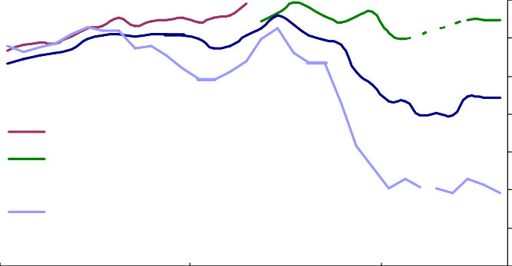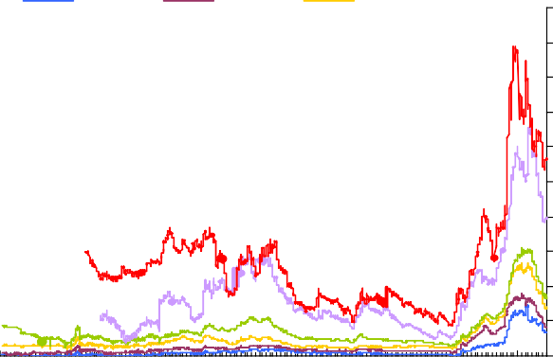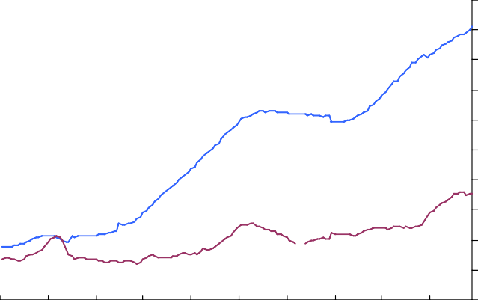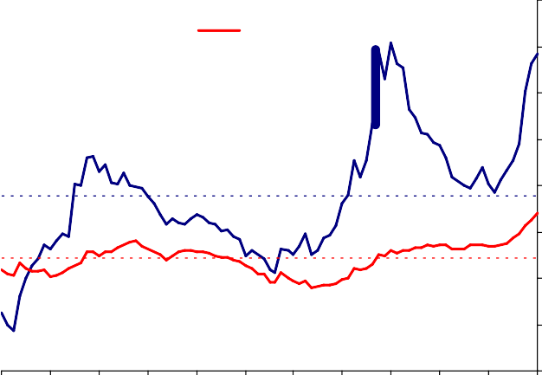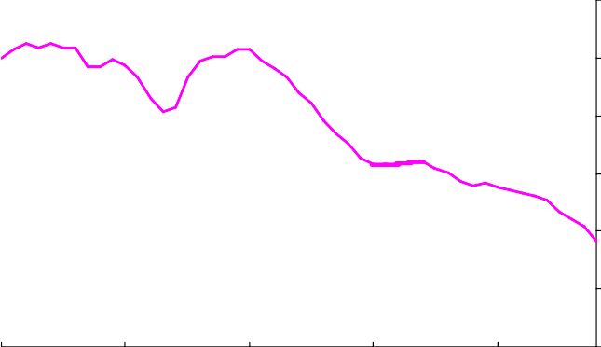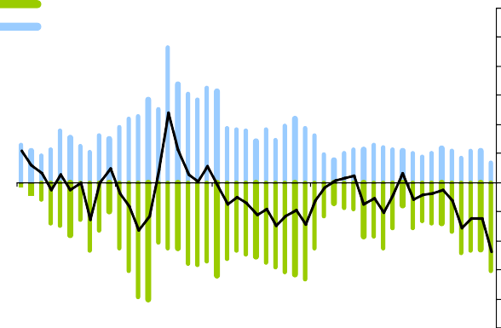

|  |  |
| --- | --- |
| **Chart 5: UK Quoted Mortgage Rates on Two Year Fixed Rate Mortgages\***  Per Cent  7  6  5  4  95% loan to value  90% loan to value 3  75% loan to value 2  2 year swap rate  1  0  2007 2008 2009  *\*End month rates. For the 95% and 90% loan to value series data is unavailable where only two or fewer products were offered during that period.* | **Chart 6: Sterling Corporate Bond Spreads**  Basis points  AAA AA A 2000  BBB BB B  1800  1600  1400  1200  1000  800  600  400  200  0  1996 1998 2000 2002 2004 2006 2008  *Source: Merrill Lynch*. *Option-adjusted asset swap spread over libor of a*  *matched floating rate bond.* |
| **Chart 7: UK Bank Lending to Households and Private Non-Financial Companies in the UK**  Percentage of GDP  100  90  80  Households 70  60  50  40  30  20  Non-financial companies 10  0  70 74 78 82 86 90 94 98 02 06  *Sources: Data includes the value of loans that have been securitised.* | **Chart 8: Capital Gearing\***  Per cent  45  Corporates Households  40  **Long-run** 35  **average**  30  25  20  15  **Long-run**  **average** 10  5  87 89 91 93 95 97 99 01 03 05 07 09  *\*Household Capital Gearing = Debt / (Financial Assets + Housing Assets) Corporate Capital Gearing = Net Debt / Market Value* |
| **Chart 9: M4 Broad Money Velocity**  Index, 1960=100  120  100  80  60  40  20  0  1960 1970 1980 1990 2000  *\*Velocity = Nominal GDP / M4 Broad Money* | **Chart 10: Change in M4 Broad Money Velocity**  change in log  M4 Broad Money 30  nominal GDP  25  Velocit y  20  15  10  5  0  -5  -10  -15  -20  -25  1960 1970 1980 1990 2000  *\*Velocity = Nominal GDP / M4 Broad Money* |
|  |  |

|  |  |
| --- | --- |
| **Chart 11: International Spot Gilt-OIS Spreads\***  QE announcement Basis points 60  Euro 40  UK 20  0  -20  US -40  -60  Sep Nov Jan Mar May Jul Sep  2009  *5 year maturities | **Chart 12: UK Corporate Bond Spreads**  Basis points Basis points  3500 750  675  3000  **inve stment grade** 600  2500 525  2000 450  375  1500 300  1000 225  **non-inve stment**  **grade** 150  500  75  0 0  Aug Nov Feb May Aug Nov Feb May Aug 2007 08 09  *Source: Merrill Lynch:Option-adjusted spread over government rates. a) aggregate indices of bonds rated BBB3 or higher. b) aggregate indices of bonds rated lower than BBB3.* |
| **Chart 13: Gross and Net Corporate Bond Issuance**  Repayments Three-month rolling sum Gross (£bns)  Net 20  15  10  5  0  -5  -10  -15  2003 2004 2005 2006 2007 2008 2009 | **Chart 14: Total Corporate Finance Raised from Capital Market and MFIs**  Borrowing from MFIs Three-month rolling sum Total Net Capital Market Issuance (£bns)  40  Net  30  20  10  0  -10  -20  -30  2003 2004 2005 2006 2007 2008 2009 |

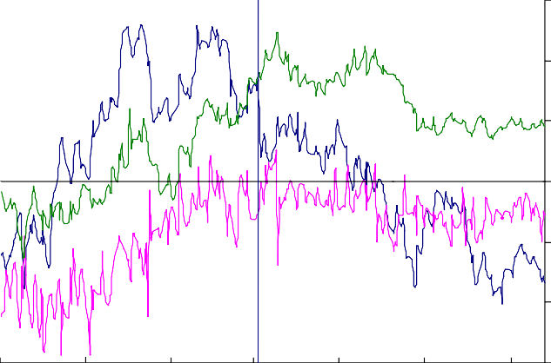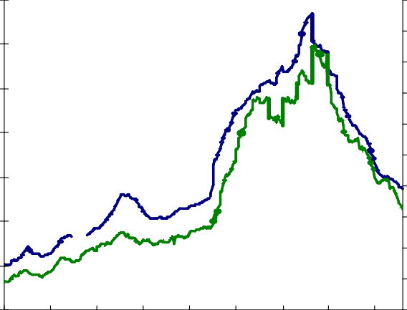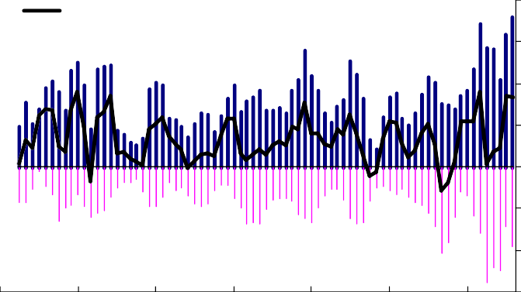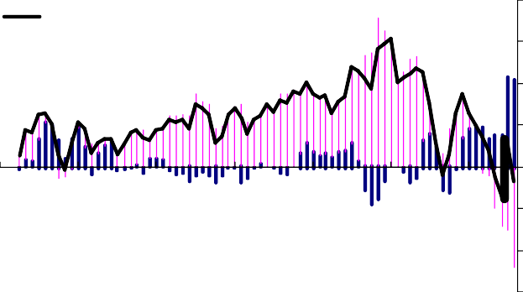

Jun Aug

Apr

Feb 09

Dec

Oct

Aug 2008

350

300

250

200

150

100

50

0

# Table A: The Variability of the Change in Money

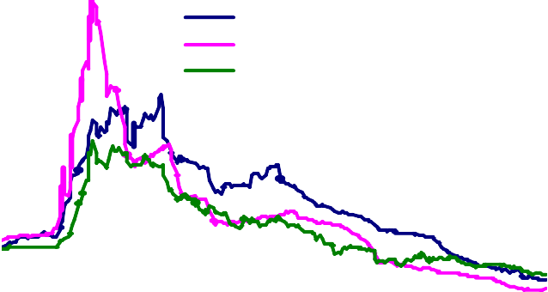

Sterling

US dollar Euro

**Chart 15: Sterling Libor-OIS 3-Month Spreads**

Basis points

400

*Calculated over the period 1960-2008* M4 Velocity Nominal GDP M4*

*Average Annual Change (%) -1.8 8.8 10.9*

*Variance / Co-variances (change in log)*

|  |  |  |  |
| --- | --- | --- | --- |
| *M4 Velocity* | *17.2* | *7.2* | *-10.1* |
| *Nominal GDP* | *7.2* | *16.7* | *9.6* |
| *M4* | *-10.1* | *9.6* | *19.6* |

*\*both the variances and co-variances are calculated from the changes in the log of each series, an approximation for the annual growth rate.*